**Saint Brigid Saint John the Baptist**

Pentecost Sunday

May 20, 2018

**Catholic Church Catholic Church**

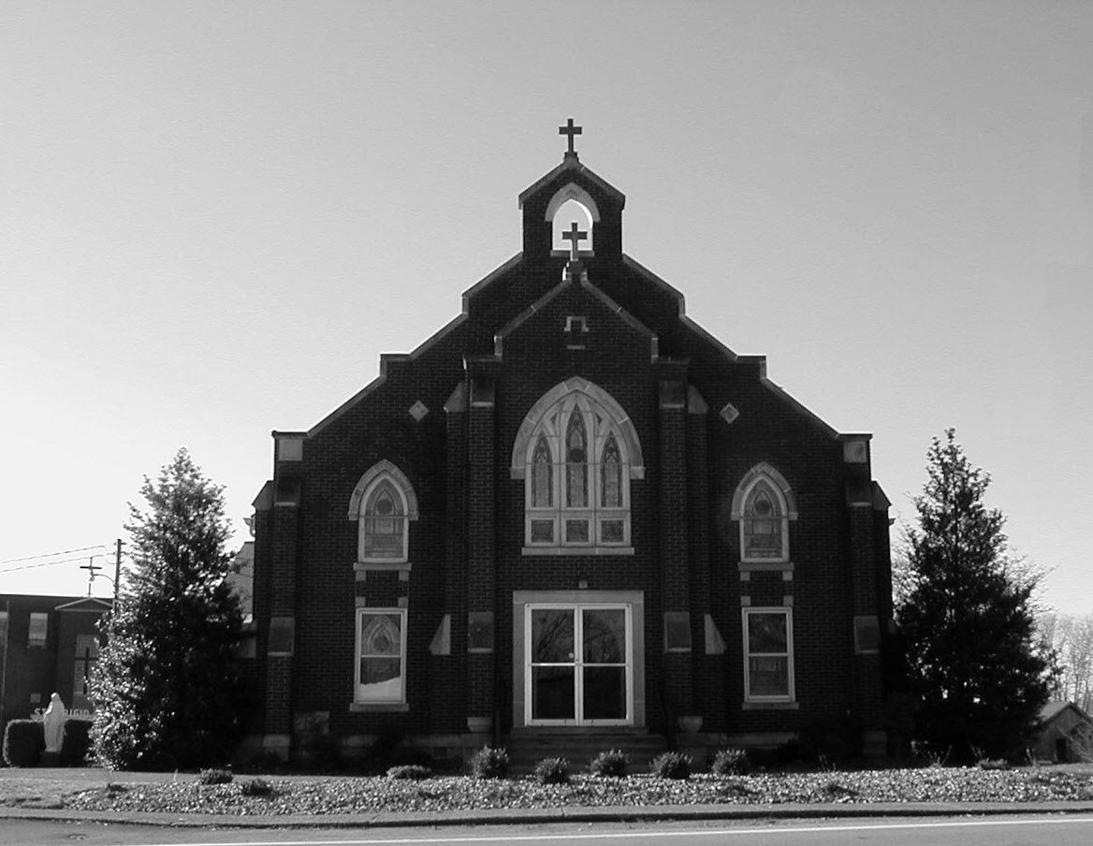

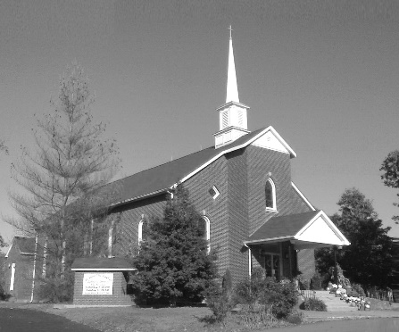

**Pastor:**

***Rev. Daniel L. Lincoln***

Rectory: (270) 877-2546

**Deacon:**

***Michael A. Ryan***

(270) 272-6789

314 E. Main St. 657 St. John Church Rd.

Vine Grove, KY 40175 Elizabethtown, KY 42701

Clustered Parish Office: Clustered Parish Office:

(270) 877-2461 (270) 877-2461

**ANNOINTING OF THE SICK:**

Notify the parish office when a family member is hospitalized.

**BAPTISM:**

Contact the parish office for information about the required preparation class.

**BULLETIN:**

Information must be submitted in writing by note or email to the parish office **no later than 12:00 noon on Wednesdays** for the following weekend. When sending an email, please put “BULLETIN,” and the name of the parish the announcement is for, in the subject line.

**MARRIAGE:**

Contact Father at least 6 months prior to the wedding date to complete required marriage preparations and to schedule the date.

**RCIA (Rite of Christian Initiation of Adults):**

Contact the Worship Chairperson for information.

**DEW MEMORIAL LIBRARY:**

(in St. Brigid Church basement):

Open: Sunday after 9:30 a.m. Mass& 45 minutes before all other Masses.

Email: [brigidvg@bbtel.com](mailto:brigidvg@bbtel.com)

Website:[www.stbrigidvg.org](http://www.stbrigidvg.org)

**Pastoral Associate & Dir. Dir. of Religious Education:**

**of Religious Education:** Lisa Thomas: (270) 735-6930

Deacon Mike Ryan: (270) 877-0546

**Youth Minister: Youth Ministers:**

Lori Law: (270) 723-0157 Angela Churchman:

(270) 268-9963

Ericka Finlay: (502) 612-2644

**MASS SCHEDULE:**

*Sunday:* 9:30 a.m. & 6:30 p.m.

*Monday:* 9:00 a.m.

*Thursday:* 9:00 a.m.

**RECONCILIATION:**

Sunday before Mass

5:30-6:00 p.m. or by appt.

**ROSARY:**

After weekday Masses

**PARISH COUNCIL MEMBERS:**

*President:* Sue Weisshaupt

*Vice-President:* Mike Bramlett

*Secretary:* Judy Cochran

*At-Large Members:* Blake Ryan

& Vincent Thompson

**CHAIRPERSONS:**

*Administration:* Dale Winchester

*Formation:* Tina Yates

*Parish Life:* Tom Billings

*Worship:* Keith Baughman

**MASS SCHEDULE:**

*Saturday (Vigil):*  6:30 p.m.

*Sunday:* 11:30 a.m.

*Wednesday:* 6:30 p.m.

*Friday:* 9:00 a.m.

**RECONCILIATION:**

Saturday before Mass

5:30-6:00p.m. or by appt.

**PARISH COUNCIL MEMBERS:**

*President:* Theresa Smith

*Secretary:* Karen Ray

**CHAIRPERSONS:**

*Administration:* Rick Newton

*Formation:* Ericka Newton

*Parish Life:* Bradley Wickersham

*Worship:* Nick Thomas



**Mass Schedule**

**Mass Schedule**

|  |  |  |  |  |  |
| --- | --- | --- | --- | --- | --- |
| **Saturday** | **May 19** | **6:30 p.m.** | **St. John** | **Living & Deceased Emil & Anna Brangers Family Members** | **Vigil: Pentecost Sunday** |
| **Sunday** | **May 20** | **9:30 a.m.** | **St. Brigid** | **Our Parish Family**  **Mack, Leanna & Billy Cecil** | **Pentecost Sunday** |
| **“** | **“** | **11:30 a.m.** | **St. John** | **For All Parishioners** | **“** |
| **“** | **“** | **6:30 p.m.** | **St. Brigid** | **Richard Hughes** | **“** |
| **Monday** | **May 21** | **9:00 a.m.** | **St. Brigid** | **Clarence “Bud” Brangers** | **Weekday** |
| **Wednesday** | **May 23** | **6:30 p.m.** | **St. John** | **For Special Intentions** | **Weekday** |
| **Thursday** | **May 24** | **9:00 a.m.** | **St. Brigid** | **Dickie Cecil**  **Arthur R. Kieta** | **Weekday** |
| **Friday** | **May 25** | **9:00 a.m.** | **St. John** | **In Thanksgiving** | **Weekday** |
| **Saturday** | **May 26** | **6:30 p.m.** | **St. John** | **Anna Brangers** | **Vigil: The Most Holy Trinity Sunday** |
| **Sunday** | **May 27** | **9:30 a.m.** | **St. Brigid** | **Our Parish Family**  **Clarence “Bud” Brangers** | **The Most Holy Trinity Sunday** |
| **“** | **“** | **11:30 a.m.** | **St. John** | **For All Parishioners** | **“** |
| **“** | **“** | **6:30 p.m.** | **St. Brigid** | **Harold Yates**  **Confirmation Class** | **“** |

**INFORMATION FOR BOTH PARISHES**

**ABORTION AND ADOPTION –** The number of would-be adoptive parents (of newborn babies) far outstrips the supply in America. Each year in the United States, about 135,000 American children are placed for adoption. Experts estimate somewhere between one and two million couples seek to adopt yearly. Every year, there are about 1.3 million abortions. Sadly, only 4% of women with unwanted pregnancies give their children up for adoption. Every child is wanted and wanted desperately! By Pro-Life Articles Author [www.pro-lifearticles.org](http://www.pro-lifearticles.org)

**PROJECT RACHEL** **–** Healing…Forgiveness…Hope…After the experience of an abortion. If you or someone you know is struggling with the pain from an abortion, please consider Project Rachel – a post abortion ministry. To speak to someone confidentially, call (502) 471-2155 or email [ProjectRachel@archlou.org](mailto:ProjectRachel@archlou.org).

**CONFIDENTIAL PREGNANCY AND ADOPTION COUNSELING** – is available at Catholic Charities for women of all ages experiencing untimely pregnancies. A full range of services are provided, including adoptive placement, legal assistance and counseling for individuals, groups and families. Post-abortion counseling is also available. Services are provided regardless of income or marital status. For more information, call Catholic Charities at (502) 637-9786.

**66th ANNUAL REGIONAL CORPUS CHRISTI PROCESSION** – Fr. Jeff Hopper and the parishioners of St. Martin of Tours parish in Flaherty want to invite all clergy and lay members of the parishes of Hardin and Meade counties to the 66th Annual Corpus Christi Procession beginning at **3:00 p.m. on Sunday, June 3, 2018** at St. Martin of Tours Catholic Church, 440 St. Martin Road, Vine Grove, KY 40175.  Let’s bring back this regional tradition of processing in parish groups with banners.  All clergy are invited to vest (please bring albs and white stoles), and altar servers from all parishes are invited to serve and vest (bring own vestments please).  All parishes please consider bringing your Religious Orders, Knights of Columbus, first communicants, and any other groups or societies.  This is a great way to show our love for our Lord in the Most Blessed Sacrament and to increase faith in His Real Presence.  Deserts and refreshments to follow.  This year’s Celebrant and Homilist will be Very Reverend Martin Linebach, Vicar General and Pastor of St. James Catholic Church.

**SAVE THE DATE** – Fr. John Judie will have a celebration of his retirement, 70th birthday and 31 years of priestly ministry on **Saturday, August 11, 2018**. More details will follow later. He may be reached at (502) 774-5772.

**St. John and St. Brigid Prayer List**

To add someone to the prayer list, please call the parish office at (270) 877-2461. **Remember to call to remove someone from the list if they are no longer sick, etc.** *Please note that the prayer list has been revised. It is primarily for parishioners and their immediate family members*.

Helen “Dinky” (Cowley) **Adams**, Sam **Adams**, April **Allen**, Dennis **Arnold**, Barbara **Ashley**, Donnie Alan **Atcher**, Sue **Banks**, Shannon **Barnes,** Denise **Barnett**, Timothy **Birch**, Teresa **Laycock**, Charlie **Bowers**, Pauline **Brangers**, Ellen **Bryan**, Richard **Bryson**, Carol **Buchanan**, Jeremy & Margie **Buyer**, Deacon Bob **Caspar**, Sue **Caswell**, Ed **Cecil**, J. Mack **Cecil**, Harlan Ford **Clark**, John **Connor**, Betty Jo **Cooper**, Heidi **Correa**, Jeff **Craig**, Glynn **Clutches**, Roan **Dowell**, Karen **Dworshak**, Leroy **Embry**, Martha **Ford**, Dwayne **Garcia**, Carrie **Gribben**, Mary **Hager**, Mrs. Charles **Hair**, Stephanie **Hall**, Donnie **Hart**, Jimmy **Harper**, Bobby **Harris**, Debbie **Hodge**, Betty Lou **Jones**, Andrew **Kieta**, Olivia **Leasor**, Jenny **Leonhardt**, Jackie **Long**, Louise **Lucous**, Alma **Mahanna**, Shelly **Martin**, Shirley **Martin**, Martina **Masoni**, Don **Mattingly**, Gerard **Mattingly**, Paul Michael **Mattingly**, Mary **Medley,** Cindy **Miller**, Starla **Miller**, Eric **Olson**, Doug **Osborne**, Duane **Osborne**, Mickey **Padgett**, Frank **Inanely**, Polly **Prather**, Annie **Pierce**, Adrianna **Porter**, Jeremy **Porter**, Adrian **Ray**, Allie **Ray**, Mary Agnes **Ray**, Mary Ellen **Ray**, James S. **Reed**, Sharon **Reed**, Tonya **Reisinger**, Joel **Rivera**, Caroline **Seabee**, Darlene **Staples**, Ralph **Staples**, Joan **Stith**, Keith **Tassin**, Kenny **Thompson**, Raffaella **Tucker**, Debi **Turner**, Stacey **Vance**, Charlotte **Vowels**, Bill **Waldrop**, Lois **Weaver**, Paul A. **Whelan**, Jennifer **Williams**, Sandy **Wiseman**, Zach **Wiseman**, Gail **Wilson**, Don **Wooldridge**, Connor **Wright**, Rose Marie **Yates** and all the sick.

* * * * * * * * * * * * * * * * * * *

**Our Military List**

To add someone to the military list, please call the parish office at (270) 877-2461. **Remember to call to remove someone from the list if they are no longer in the service**.

Lt. Matt **Bednar**, PFC Richard H. **Chapman**, A1C Aaron **Chandler**, A1C Brandon **Davila**, SrA Felicia **Esquivel**, PFC Tyler **Hall**, A1C Ryan **Henley**, A1C Joseph **Manco**, SPC Jacob L. **Nall**, SFC Peter **Novak**, Tony **Rickerl**, Lt. Col. Paul **Rigby**, 0James **Rogers**, Tony **Rogers**, Jonathon **Sifford**, Jeffrey **Slade**, Derek **Smith**, CSM Vance **Snider**, Brian **Tomassi**, A1C Daniel **Trombone**, SGT Evan **Vaughan**, PV2 William **Vaughan**, Lisa **Flynn-Veri**, LT Michael **Veri**, LTC Steve **Wickersham**, SGT Clay **Wilson**, TSGT Jeremy **Yates**, Austin **Zulka** and for all who serve and have served our country.

* * * * * * * * * * * * * * * * * * *

**ST. JOHN THE BAPTIST CATHOLIC CHURCH INFORMATION**

**Monthly Budget Amount Needed:** $ 12,500.00

**Monthly Collection for April:** $ 12,822.41

**Monthly Collection for May:** $ 5,534.70

**WELCOME PACKETS** – If you would like to become a member, or learn more about St. John Parish, please take a *Welcome Packet* in the church lobby. You may return the census card and the stewardship form to Father Dan or place in the collection basket.

**CONGRATULATIONS** – and prayers for our high school seniors: Kaitlyn Davis, Logan Greenwell and Ben Thomas.

**CATHOLIC WORLD MISSION** – This door collection will be this weekend.

**CONGRATULATIONS** – to Margaret Emrie Hatfield, daughter of Casey and Elise (Wiseman) Hatfield, who was Baptized last week.

**THANKS** – to our parents and students for another year of Religious Education, and especially for the following teachers and substitutes for their gift of time, talent and treasure. Teachers: Jenny Bischoff, Vince Carlotti, Kim Compton, Angie Geer, Elaine Geer, Sharon Kennedy, Sara Kuhn, Abby Newton, Ericka Newton, Vicki Taylor and Clarissa Yates. Substitutes:  Angela Churchman, Terry Carlotti, Melanie Goode, Aimee Hunt, Rhonda Newton, Dayna Parrett, Tracie Price, Greg Thompson and Pam Yates. Enjoy your summer! Don't forget VBS in July and remember our faith is always with us so continue your spiritual journey till we meet again in the fall.

**STEWARDSHIP FAIR** – Mark your calendars for the upcoming Stewardship Fair. Before and after Mass on **Saturday, May 19 and Sunday, May 20.** We’re starting from scratch, so we are counting on everyone’s cooperation.

**PARISH COUNCIL** – will meet on **Monday, May 21, at 6:30 p.m.** in the Parish Hall.

**ALTAR SERVERS** – On **Sunday, May 27,** there will be an altar server practice immediately after the 11:30 a.m. Mass. This will be for all servers to improve their skills but primarily for new server candidates. Requirements for new servers are to have completed both 1st Communion, 1st Confession and be in 4th grade and up. Third Graders may be considered if the above requirements are met and with Fr. Dan’s permission.

**SAVE THE DATE – VACATION BIBLE SCHOOL** – will be **Sunday-Thursday, July 15-19, from 6:00-8:30 p.m.** Make plans now for a great week! If you have any questions, contact Clarissa Yates, [cpyates@comcast.net](mailto:cpyates@comcast.net) or (270) 862-3792.

**FR. STAN OSBORNE** – can be reached at Nazareth Home, Room 112, 2000 Newburg Rd., Louisville, KY 40205.

* * * * * * * * * * * * * * * * * * *

**St. John Liturgical Ministers**

|  |  |
| --- | --- |
| **Vigil: The Most Holy Trinity Sunday, May 26, 2018, 6:30 p.m.** |  |
| Extraordinary Ministers of the Eucharist | Becky Thomas Marcella Crewz Dennis Thomas |
| Lector | Tony Smith |
| Servers | Volunteers |
| Greeter(s) | Hannah Thomas |
| Gift Bearers | Becky Thomas & Carol Goodin |
| - Ushers | Jonathan French & Zach Heibert |
| **The Most Holy Trinity Sunday, May 27, 2018, 11:30 a.m.** |  |
| Extraordinary Ministers of the Eucharist | Raeburn Mattingly Lucy Ramos Martha Thomas |
| Lector | Scott Mattingly |
| Servers | Claire Thomas Melia Reddick |
| Greeter(s) | Barbara Ashley |
| Gift Bearers | Steve & Sandi Brangers |
| Ushers | Trent Thomas & Joe Samu |
| **Hospital Ministry – Sunday, May 27, 2018** | Marcella Brangers |

**ST. BRIGID CATHOLIC CHURCH NFORMATION**

**Monthly Budget Amount Needed:** $ 25,280.00

**Monthly Collection for April:** $ 34,233.18

**Monthly Collection for May:** $ 14,068.00

**WELCOME VISITORS** – If you are interested in joining our parish, please pick up a Welcome Packet at the church doors. Complete the registration form and either drop it in the collection basket or mail it to the office. If you just need to update your registration, there are also forms available.

**CHANGE OF DATE** – The Mary video/coffee/donuts will be held on **Sunday, May 27** after the 9:30 a.m. Mass in the CMR.

**CONGRATULATIONS** – and prayers for our high school seniors: Emily Chandler, Brooks Dowdell, Alyssa Dowdell, Amber Eitutis, Camilia Falcon’, Wes Irwin, Avery Knock, Paul Kotarski, Evan Mahanna, Jacob Moss and Jasper New.

**CATHOLIC WORLD MISSIONS** – This annual second collection will be taken after Communion at today’s Masses.

**DISCERNMENT IN ACTION!!!!** The discernment committee did the first official Service and Outreach Project at Hooray for Heroes Saturday, May 19. We gave out Saint Brigid pencils, candy, and provided a flyer about St. Brigid Church. Saint Brigid volunteers and discernment core team members manned our booth. Our next meeting is **Sunday, June 10,** immediately following the 9:30 a.m. Mass. Anyone interested in attending this meeting to learn more about the Outreach opportunities is encouraged to attend.  The meeting will be in the School Meeting Room. For additional information please contact Deacon Mike Ryan (270) 877-0546 or (270) 272-6789 or [mryan@bbtel.com](mailto:mryan@bbtel.com).

**SUMMER EVENT ENVELOPE** – Please turn in your Summer Event offering envelope. It should have been in your March envelopes. This helps us pay for the printing of the Summer Event tickets and the dinner tickets and a few other things. Should you have any questions, please contact Deacon Mike.

**KNIGHTS OF COLUMBUS APPALACHIAN MISSION** – Volunteers will be going again to the Appalachian Mountains to repair some houses at the end of May. The Mission Center we work out of is going through a restructuring process and is moving to a new address. This year due to their restructuring, we will not be taking any homewares. However, we would appreciate any donation of lumber and supplies. Make checks payable to the Knights of Columbus State Charities and mail to Charles E. Jones, 500 Milimish Rd., Vine Grove, Ky 40175. Thank you.

**SAVE THE DATE** – Please join us for a 50th Wedding Anniversary Celebration in honor of Dr. Anthony and Tina Yates which will take place in the K of C Hall after the 9:30 a.m. Mass on **Sunday, May 20.**

**ST. BRIGID CONFIRMATION CANDIDATES 2018** – Please pray for the following candidates as they prepare to receive Confirmation on **Sunday, May 27,** at the 6:30 p.m. Mass:

Riley Bryant Michael Mayes

Breanna Davison Caraline New

Ridge Disselkamp Molly New

Reece Dowdell Nicholas Sanders

Morelia Falc’on Emily Savoni

Kyle Fowler Thomas Webb

Jaden Hicks Mollie Weisshaupt

**BLOOD DRIVE** – The next drive will be held on **Friday, June 15,** from 10:00 a.m.-2:00 p.m. in the CCC building. Give the gift of life!! This is more rewarding than what else you have to do today!!

**SUMMER EVENT** – The Summer Event will be **Sunday, September 16**. That way we are not competing with St. Martin’s picnic or the Vine Grove Autumn festival. The lunch is from 1:00-3:00 p.m. The silent auction ends at 3:45 p.m. The main drawing will be at 4:00 p.m. Diane Taylor will cater the meal.  She can do a BBQ pork sandwich, baked beans, either claw slaw or potato salad, sweet and unsweet tea and, water.  She will also do a hot dog for children (or adults that don't want BBQ). We will have the food served in the new cafeteria.  We would still need teens to help serve drinks and bus tables and clean up like we do at the KC Hall now. The Summer Event Ticket Order Forms are at the side doors of the church and the table in the back of church. Should anyone need additional information please contact Teresa Morgan (270) 862-2909; Gina Ryan (270) 735-6355 or Deacon Mike Ryan (270) 877-0546 or (270) 272-6789.

**COMMUNION MINISTER UPDATE SESSIONS** – are for those ministers needing a mandate renewal, who have already completed the archdiocesan two-session Communion Minister Formation Program. This session will fulfill the requirements for continuing formation for Extraordinary Ministers of Holy Communion. I have scheduled the mandatory update session for **September 27, 2018 from 7:00- 9:00 p.m.** Please add to your calendar. I will put the form applications out three weeks before and make sure a new announcement gets into the bulletin. Should you have questions please contact Deacon Mike.

* * * * * * * * * * * * * * * * * * *

**St. Brigid Youth Ministry**

**Wednesday, May 24** – Youth night in the CCC for all 8th-12th graders. Join us from 6:30-8:30 p.m. for fun & fellowship.

**Christian Leadership Retreat** – will run from **July 9-13** and is for anyone who has completed their sophomore or junior year of high school. Please contact Lori for more details and permission forms if you are interested. The sooner you apply the better chance of getting a spot and the cheaper it is.

If you have any questions, please contact Lori at (270) 723-0157 or email at [stbrigidyouth@hotmail.com](mailto:stbrigidyouth@hotmail.com).

**St. Brigid Monthly Meet and Greet**

St. Brigid Parish hosts a “Meet and Greet” downstairs the 2nd Sunday of each month immediately following the 9:30 a.m. Mass with coffee and donuts. This is a great opportunity for existing parishioners to extend a warm welcome to visitors and anyone interested in joining St. Brigid Parish. Be sure to also visit the Dew Memorial Library.

**The next Meet and Greet will be Sunday, June 10, 2018.**

**St. Brigid Liturgical Ministers**

|  |  |
| --- | --- |
| **The Most Holy Trinity Sunday, May 27, 2018, 9:30 a.m.** |  |
| Extraordinary Ministers of the Eucharist P. | Mark Kelly Denise Hester |
| C. | Janey Jenkins Danny Board David Stoddard Alison Dupont |
| Lector | Selina Chandler |
| Servers | Alexander Lozano Cal Yates |
| Greeters | Keith & Martha Baughman Chad Sims |
| **The Most Holy Trinity Sunday, May 27, 2018, 6:30 p.m.** |  |
| Extraordinary Ministers of the Eucharist P. | Richard Osterhage |
| C. | Donna Osterhage Ron Masoni |
| Lector | Kathleen Bramlett |
| Servers | Nathaniel Morgan Christopher Morgan |
| Greeters | Volunteers |
| **Hospital Ministry – Sunday, June 10, 2018** | Ralph & Sherleen Barren |

***Marriage Moments*** –

Pentecost is a feast of fear, community and bravery. Have you ever feared for the safety of your spouse? When? What help you keep your marriage vows? Have you ever needed to defend you spouse to others? Stand up for each other’s goodness. Gently and privately correct if necessary.

***Parenting Pointers*** –

Pentecost refers to 50 days after Easter. It reminds us of fear, community and bravery. The apostles were afraid after Jesus left them. They gathered together. The Spirit filled them with courage to speak out. Ask your family what helps them be brave. Can anyone identify a recent courageous act?



“Peace be with you. Receive the Holy Spirit.”